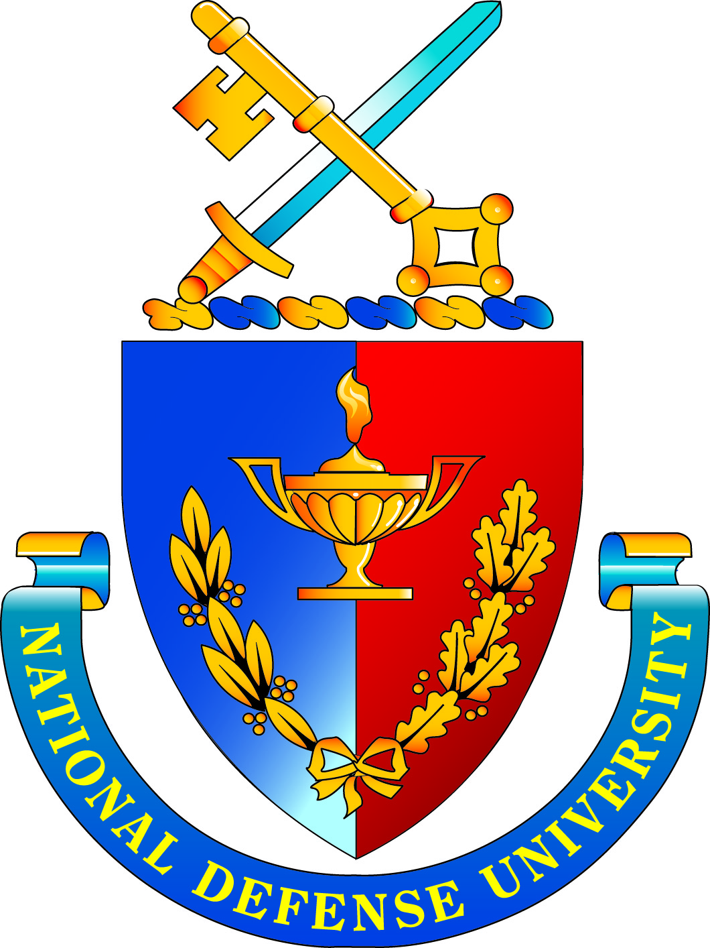 | National Defense University  Board of Visitors Meeting  December 10-11, 2012  AGENDA

Monday, December 10, 2012

0900 Call to Order Dr. Brenda Roth, Designated Federal
Officer (DFO) and Deputy Vice President for Academic Affairs

0900-0905 Administrative Notes Dr. Brenda Roth
General Lloyd Newton, USAF (Retired)

0905-1000 Remarks Lieutenant General George Flynn
Director, Joint Force Development (J-7)

1000-1115 State of the University Major General Gregg F. Martin, Ph.D.
14th President

1115-1215 Middle States Commission on Higher Dr. John Yaeger, VP, Academic Affairs
Education/Characteristics of Excellence Colonel Stewart Liles, Chief Information Officer

1230-1330 Lunch

1345-1500 NDU Governance Dr. John Yaeger VP, Academic Affairs

1500-1515 BREAK

1515-1630 NDU Finances Mr. Jay Helming, Director, Resources Ms. Cathleen Pearl, NDU Foundation

1630 Meeting Ends for the Day Dr. Brenda Roth

Tuesday, December 11, 2012

0900 Call to Order Dr. Brenda Roth

0900-0915 Group Photo Board and Select Senior Leaders

0915-0930 Honorary Degree Dr. John Yaeger

0930-1045 NDU Task Force 2020 Dr. Michael S. Bell
Chancellor, CISA

1045-1145 Managing Human Capital Ms. Lynn Simpson, Senior Advisor,
Human Resources

1145-1230 Wrap-up Board Members/General Martin

1230 Meeting Adjourns Dr. Brenda Roth

