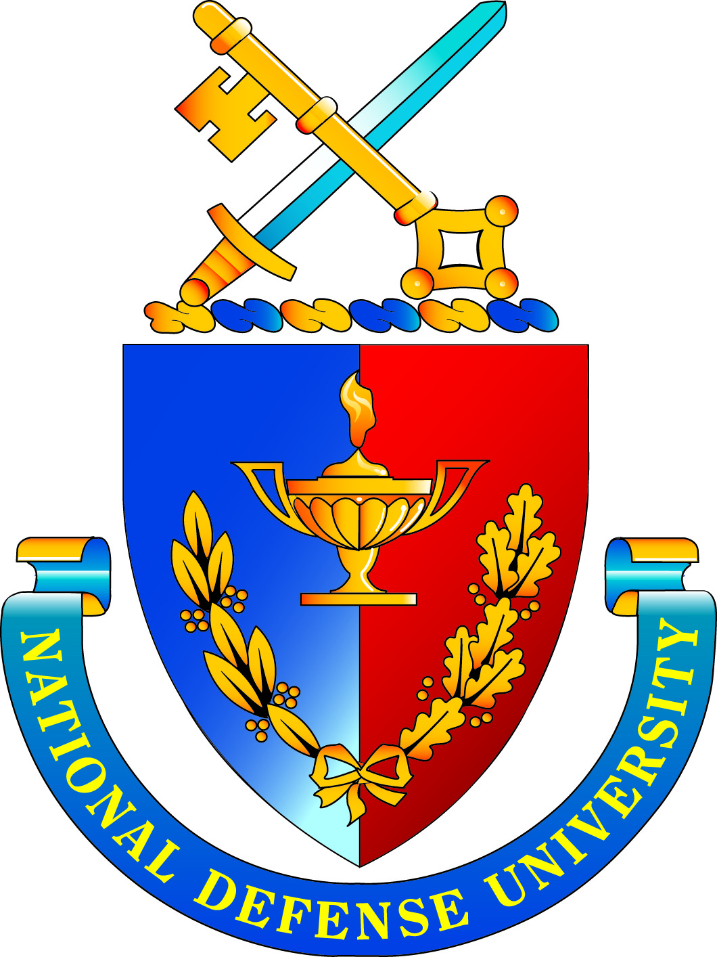 | National Defense University  Board of Visitors Meeting  14 March 2014  AGENDA
Friday, March 14 2014
BOV Meeting, Room 2315, Lincoln Hall

1430 Call to Order Dr. Brenda Roth, Designated Federal
Officer (DFO) and Deputy Vice President for Academic Affairs

1430-1435 Administrative Notes Dr. Brenda Roth
(DFO comments/overview of agenda, General Lloyd Newton, USAF (Retired),
approval of last meeting’s minutes) BOV Chair

1435-1450 Remarks Major General Gregg F. Martin, Ph.D.
14th President, NDU

1450-1520 NDU’s Joint Education Transformation Dr. John Yaeger, Provost, NDU
Initiative

1520-1605 Question and Answer Period Board Members

1605-1620 Public Comment Period

1620-1635 Closing Remarks Major General Martin
General (Ret.) Newton

1635 Meeting Adjourns Dr. Roth

